 **OLYMPIC GAMES**

**DATABASE MANAGEMENT SYSTEM**

Problem Statement:

The database will contain important information about the event organization and will be accessible to International Olympic Committee. This database will contain the details of the Athletes, participating countries, fixtures, event participation, information about the various games organized (group and individual), venues and services, results and leader board.

This database management system will help the International Olympic Committee to access various types of information and improve the quality of conduction of these games in the future. They can also keep track of the various services and equipment required during the games and assess how many more will be needed.

**CONTENTS**:

* ER Model Assumptions
* ER Diagram
* Tables
* Functional Dependencies and Primary Keys
* Normalization
* Relational Schema with Normalized tables
* SQL Code

Name: Ishika Jaiswal

Roll No: 21MMB0A24

Batch: 2021-25

**ER MODEL ASSUMPTIONS:**

1. All sports taken are solo events
2. An athlete participates in one sport only.

**ER DIAGRAM:**

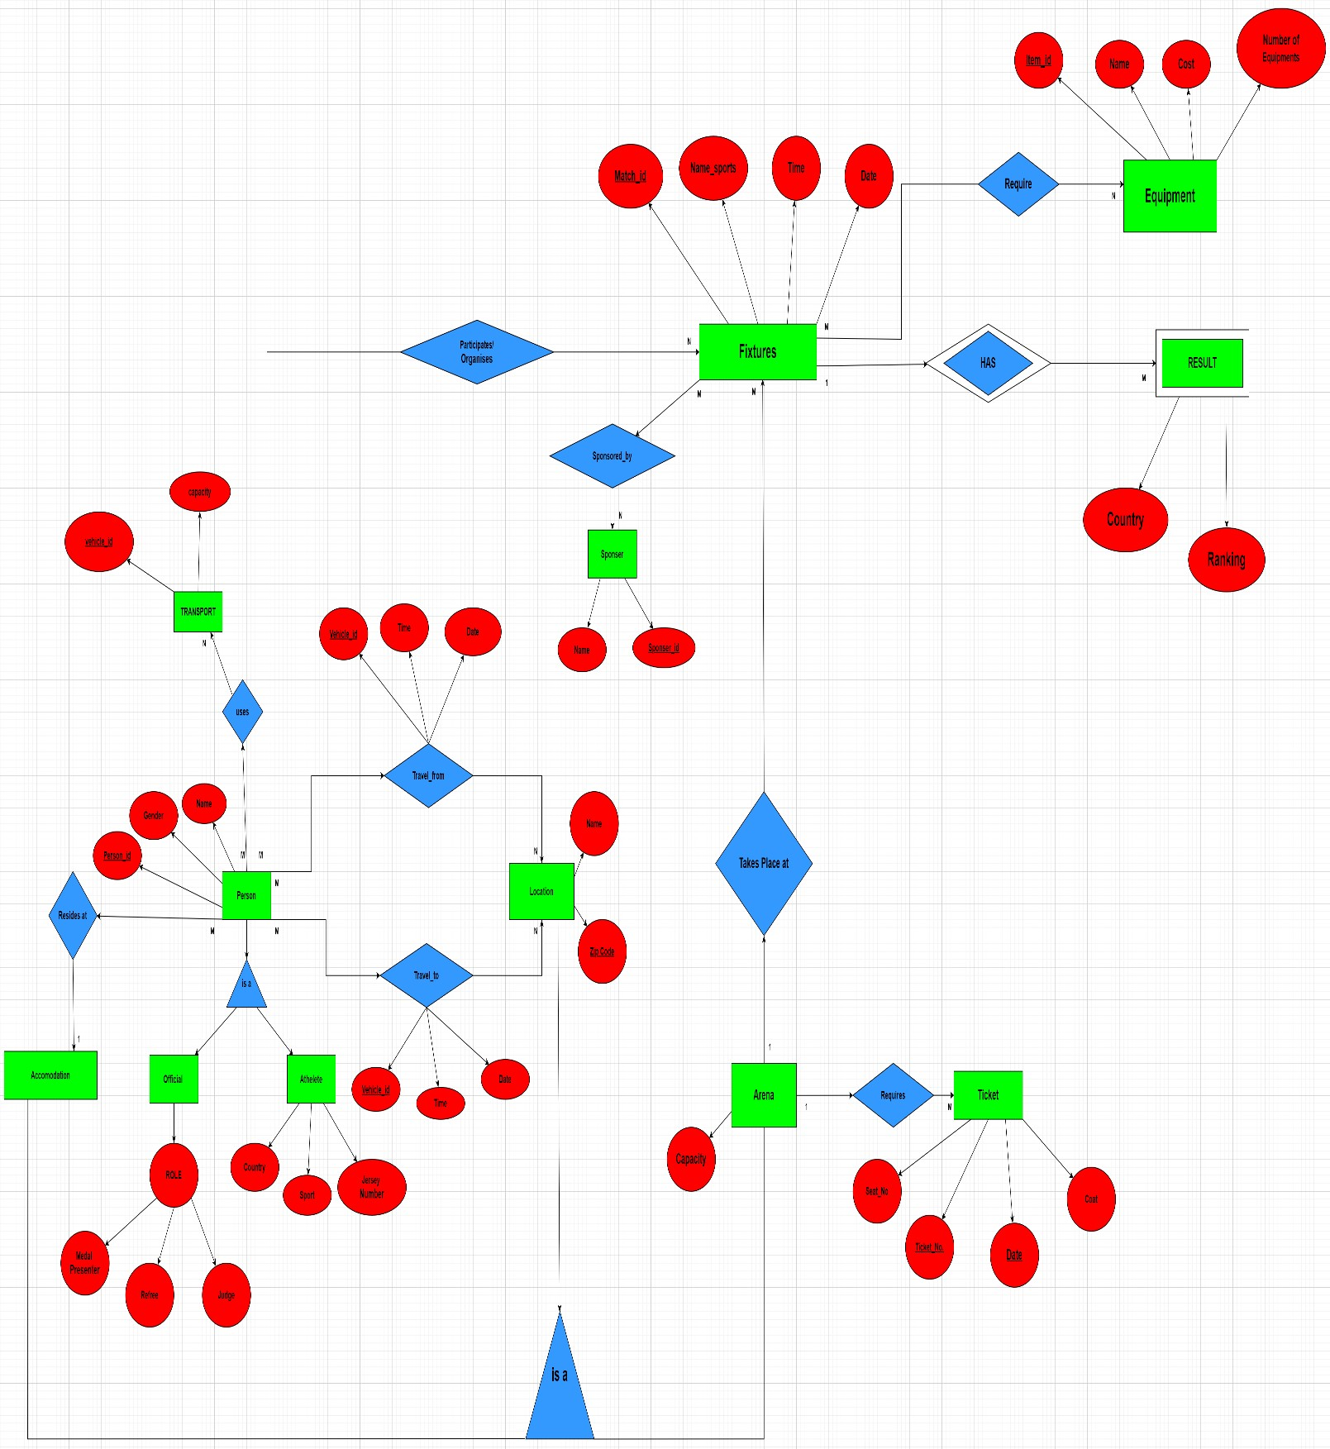

**TABLES:**

1) EQUIPMENT

|  |  |  |
| --- | --- | --- |
| **Attribute** | **Datatype** | **Constraints and Characteristics** |
| Item_Id | INT | NOT NULL, PRIMARY KEY |
| Name_e | VARCHAR | NOT NULL |
| Cost | INT | NOT NULL |
| Number_of_equipment | INT | NOT NULL |

# 2)SPONSORS

|  |  |  |
| --- | --- | --- |
| **Attribute** | **Datatype** | **Constraints and Characteristics** |
| Name_s | VARCHAR | NOT NULL |
| Sponsor_Id | INT | NOT NULL, PRIMARY KEY |

# 3)TRANSPORT

|  |  |  |
| --- | --- | --- |
| **Attribute** | **Datatype** | **Constraints and Characteristics** |
| Vehicle_Id | VARCHAR | NOT NULL, PRIMARY KEY |
| Capacity | INT | NOT NULL |

# 4)LOCATION

|  |  |  |
| --- | --- | --- |
| **Attribute** | **Datatype** | **Constraints and Characteristics** |
| Name_l | VARCHAR | NOT NULL, PRIMARY KEY |
| Zip-code | INT | NOT NULL, PRIMARY KEY |

# 5)ARENA

|  |  |  |
| --- | --- | --- |
| **Attribute** | **Datatype** | **Constraints and Characteristics** |
| Capacity | INT | NOT NULL |
| Name_l | VARCHAR | NOT NULL, PRIMARY KEY,FOREIGN KEY |
| Zip-code | INT | NOT NULL, PRIMARY KEY, FOREIGN KEY |

# 6)TICKETS

|  |  |  |
| --- | --- | --- |
| **Attribute** | **Datatype** | **Constraints and Characteristics** |
| Seat_Number | INT | NOT NULL |
| Ticket_Number | INT | NOT NULL, PRIMARY KEY |
| Date | DATE | NOT NULL |
| Cost | INT | NOT NULL |
| Name_l | VARCHAR | NOT NULL, FOREIGN KEY |
| Zip-code | INT | NOT NULL, FOREIGN KEY |

# 7)ACCOMODATION

|  |  |  |
| --- | --- | --- |
| **Attribute** | **Datatype** | **Constraints and Characteristics** |
| Name_l | VARCHAR | NOT NULL, PRIMARY KEY, FOREIGN KEY |
| Zip-code | INT | NOT NULL, PRIMARY KEY, FOREIGN KEY |

# 8)FIXTURES

|  |  |  |
| --- | --- | --- |
| **Attribute** | **Datatype** | **Constraints and Characteristics** |
| Match_Id | VARCHAR | NOT NULL, PRIMARY KEY |
| Name_Sports | VARCHAR | NOT NULL |
| Time | VARCHAR | NOT NULL |
| Date_f | DATE | NOT NULL |
| Name_l | VARCHAR | NOT NULL, FOREIGN KEY |
| Zip-code | INT | NOT NULL, FOREIGN KEY |

# 9)RESULT

|  |  |  |
| --- | --- | --- |
| **Attribute** | **Datatype** | **Constraints and Characteristics** |
| Country | VARCHAR | NOT NULL, PRIMARY KEY |
| Ranking | INT | NOT NULL |
| Match_Id | VARCHAR | NOT NULL, PRIMARY KEY, FOREIGN KEY |

# 10)SPONSORED_BY

|  |  |  |
| --- | --- | --- |
| **Attribute** | **Datatype** | **Constraints and Characteristics** |
| Sponsor_Id | INT | NOT NULL, FOREIGN KEY |
| Match_Id | VARCHAR | NOT NULL, FOREIGN KEY |

# 11)REQUIRE

|  |  |  |
| --- | --- | --- |
| **Attribute** | **Datatype** | **Constraints and Characteristics** |
| Item_Id | INT | NOT NULL, FOREIGN KEY |
| Match_Id | VARCHAR | NOT NULL, FOREIGN KEY |

# 12)PERSON

|  |  |  |
| --- | --- | --- |
| **Attribute** | **Datatype** | **Constraints and Characteristics** |
| Name | VARCHAR | NOT NULL |
| Person_Id | VARCHAR | NOT NULL, PRIMARY KEY |
| Gender | VARCHAR | NOT NULL |
| Name_l | VARCHAR | NOT NULL, FOREIGN KEY |
| Zip-code | INT | NOT NULL, FOREIGN KEY |

# 13)PARTICIPATES_ORGANISES

|  |  |  |
| --- | --- | --- |
| **Attribute** | **Datatype** | **Constraints and Characteristics** |
| Match_Id | VARCHAR | NOT NULL, FOREIGN KEY |
| Person_Id | VARCHAR | NOT NULL, FOREIGN KEY |

# 14)TRAVELS_FROM

|  |  |  |
| --- | --- | --- |
| **Attribute** | **Datatype** | **Constraints and Characteristics** |
| Time | VARCHAR | NOT NULL |
| Date | DATE | NOT NULL |
| Name_l | VARCHAR | NOT NULL, FOREIGN KEY |
| Zip-Code | INT | NOT NULL, FOREIGN KEY |
| Person_Id | VARCHAR | NOT NULL, FOREIGN KEY |
| Vehicle_Id | VARCHAR | NOT NULL, FOREIGN KEY |

# 15)TRAVELS_TO

|  |  |  |
| --- | --- | --- |
| **Attribute** | **Datatype** | **Constraints and Characteristics** |
| Time | VARCHAR | NOT NULL |
| Date | DATE | NOT NULL |
| Name_l | VARCHAR | NOT NULL, FOREIGN KEY |
| Zip-Code | INT | NOT NULL, FOREIGN KEY |
| Person_Id | VARCHAR | NOT NULL, FOREIGN KEY |
| Vehicle_Id | VARCHAR | NOT NULL, FOREIGN KEY |

# 16)OFFICIAL

|  |  |  |
| --- | --- | --- |
| **Attribute** | **Datatype** | **Constraints and Characteristics** |
| Person_Id | VARCHAR | NOT NULL, PRIMARY KEY, FOREIGN KEY |
| Medal_Presenter | CHAR (1) | NOT NULL |
| Referee | CHAR (1) | NOT NULL |
| Judge | CHAR (1) | NOT NULL |

# 17)ATHELETE

|  |  |  |
| --- | --- | --- |
| **Attribute** | **Datatype** | **Constraints and Characteristics** |
| Person_Id | VARCHAR | NOT NULL, PRIMARY KEY, FOREIGN KEY |
| Sport | VARCHAR | NOT NULL |
| Country | VARCHAR | NOT NULL |
| Jersey_Number | INT | NOT NULL |

# 18)USES

|  |  |  |
| --- | --- | --- |
| **Attribute** | **Datatype** | **Constraints and Characteristics** |
| Vehicle_Id | VARCHAR | NOT NULL, FOREIGN KEY |
| Person_Id | VARCHAR | NOT NULL, FOREIGN KEY |

**FUNCTIONAL DEPENDENCIES & PRIMARY KEY**

1. **EQUIPMENT:**

Item_Id -> {Item_Id, Name_e, Cost, Number_Of_Equipment}

Since all the fields depend on Item_Id, (Item_Id) + -> R.

Hence, Item_Id is Primary Key.

1. **SPONSORS:**

Sponsor_Id -> {Sponsor_Id, Name_s}

Since all the fields depend on Sponsor_Id, (Sponsor_Id) + -> R.

Hence, Sponsor_Id is Primary Key.

## 3) TRANSPORT

Vehicle_Id -> {Vehicle_Id, Capacity}

Since all the fields depend on Vehicle_Id, (Vehicle_Id) + -> R.

Hence, Vehicle_Id is Primary Key.

## 4) LOCATION

{Name_l, Zip-code} -> {Name_l, Zip-code}

Since all the fields depend on {Name_l, Zip-code}, {Name_l, Zip-code} +-> R.

Hence, {Name_l, Zip-code} is Primary Key.

## 5) ARENA

{Name_l, Zip-code} -> {Name_l, Zip-code, Capacity}

Since all the fields depend on {Name_l, Zip-code}, {Name_l, Zip-code} +-> R.

Hence, {Name_l, Zip-code} is Primary Key.

## 6) TICKETS

{Ticket_number, Date} {Ticket_number, Date, Seat_number, Cost, Name_l, Zip-code}

Since all the fields depend on {Ticket_number, Date}, {Ticket_number, Date} + -> R.

Hence, {Ticket_number, Date} is Primary Key.

## 7) ACCOMODATION

{Name_l, Zip-code} -> {Name_l, Zip-code}

Since all the fields depend on {Name_l, Zip-code}, {Name_l, Zip-code} +-> R.

Hence, {Name_l, Zip-code} is Primary Key.

## 8) FIXTURES

Match_Id -> {Match_Id, Name_Sports, Time, Date_f, Name_l, Zip-code }

Since all the fields depend on Match_Id, (Match_Id)+ -> R.

Hence, Match_Id is Primary Key.

## 9) RESULT

{Match_Id, Country} -> {Match_Id, Country, Ranking}

Since all the fields depend on {Match_Id, Country}, ({Match_Id, Country})+ -> R.

Hence, {Match_Id, Country} is Primary Key.

## 10)PERSON

Person_Id -> {Name, Person_Id, Gender, Name_l, Zip-code} Since all the fields depend on Person_Id, (Person_Id) + -> R.

Hence, Person_Id is Primary Key.

## 11) OFFICIAL

Person_Id -> {Person_Id, Medal_Presenter, Referee, Judge} Since all the fields depend on Person_Id, (Person_Id) + -> R.

Hence, Person_Id is Primary Key.

## 12) ATHELETE

Person_Id -> {Person_Id, Country, Sport, Jersey_Number}

Since all the fields depend on Person_Id, (Person_Id) + -> R.

Hence, Person_Id is Primary Key

**NORMALISATION:**

## 1) EQUIPMENT

Primary key: Item_Id

All attributes depend on the Item_Id, hence the table is 2NF.

All attributes depend directly on Item_Id, hence the table is in 3NF.

All determinants (Item_Id) are candidate keys, hence the table is in BCNF

## 2) SPONSORS

Primary key: Sponsor_Id

All attributes depend on the Sponsor_Id, hence the table is 2NF.

All attributes depend directly on Sponsor_Id, hence the table is in 3NF.

All determinants (Sponsor_Id) are candidate keys, hence the table is in BCNF.

## 3) TRANSPORT

Primary key: Vehicle_Id

All attributes depend on the Vehicle_Id, hence the table is 2NF.

All attributes depend directly on Vehicle_Id, hence the table is in 3NF.

All determinants (Vehicle_Id) are candidate keys, hence the table is in BCNF.

**4) LOCATION**

Primary key: {Name_l, Zip-code}

All attributes depend on the {Name_l, Zip-code}, hence the table is 2NF.

All attributes depend directly on {Name_l, Zip-code}, hence the table is in 3NF.

All determinants {Name_l, Zip-code} are candidate keys, hence the table is in BCNF.

## 5) ARENA

Primary key: {Name_l, Zip-code}

All attributes depend on the {Name_l, Zip-code}, hence the table is 2NF.

All attributes depend directly on {Name_l, Zip-code}, hence the table is in 3NF.

All determinants {Name_l, Zip-code} are candidate keys, hence the table is in BCNF.

## 6) TICKETS

Primary key: {Ticket_number, Date}

All attributes depend on the {Ticket_number, Date}, hence the table is 2NF.

All attributes depend directly on {Ticket_number, Date}, hence the table is in 3NF.

All determinants {Ticket_number, Date} are candidate keys, hence the table is in BCNF.

## 7) ACCOMODATION

Primary key: {Name_l, Zip-code}

All attributes depend on the {Name_l, Zip-code}, hence the table is 2NF.

All attributes depend directly on {Name_l, Zip-code}, hence the table is in 3NF.

All determinants {Name_l, Zip-code} are candidate keys, hence the table is in BCNF.

## 8) FIXTURES

Primary key: Match_Id

All attributes depend on the Match_Id, hence the table is 2NF.

All attributes depend directly on Match_Id, hence the table is in 3NF.

All determinants (Match_Id) are candidate keys, hence the table is in BCNF.

## 9) RESULT

Primary key: {Match_Id, Country}

All attributes depend on the {Match_Id, Country}, hence the table is 2NF.

All attributes depend directly on {Match_Id, Country}, hence the table is in 3NF.

All determinants {Match_Id, Country} are candidate keys, hence the table is in BCNF.

## 10)PERSON

Primary key: Person_Id

All attributes depend on the Person_Id, hence the table is 2NF.

All attributes depend directly on Person_Id, hence the table is in 3NF.

All determinants (Person_Id) are candidate keys, hence the table is in BCNF.

## 11) OFFICIAL

Primary key: Person_Id

All attributes depend on the Person_Id, hence the table is 2NF.

All attributes depend directly on Person_Id, hence the table is in 3NF.

All determinants (Person_Id) are candidate keys, hence the table is in BCNF.

## 12) ATHELETE

Primary key: Person_Id

All attributes depend on the Person_Id, hence the table is 2NF.

All attributes depend directly on Person_Id, hence the table is in 3NF.

All determinants (Person_Id) are candidate keys, hence the table is in BCNF.

**RE**

**L**

**ATIONAL SCHEMA:**

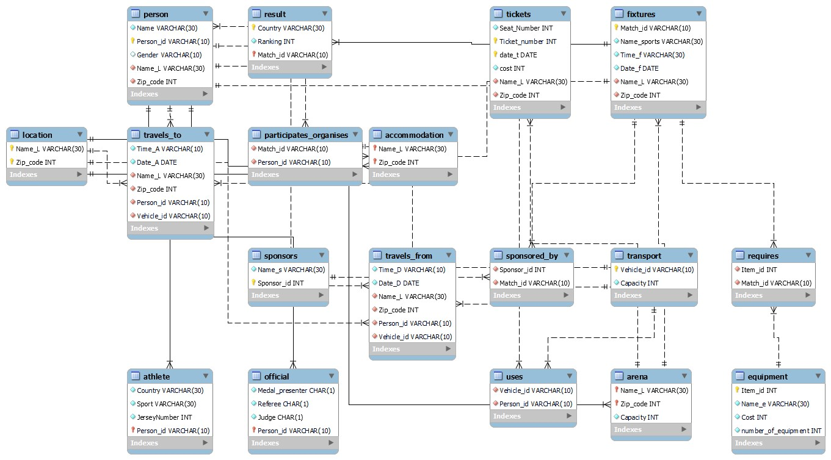

**SQL CODES:**

Table Creation:

create database olympic_games;

CREATE TABLE Equipment

(

Item_id INT NOT NULL,

Name_e VARCHAR(30) NOT NULL, Cost INT NOT NULL, number_of_equipment INT NOT NULL,

PRIMARY KEY (Item_id)

);

CREATE TABLE Sponsors

(

Name_s VARCHAR(30) NOT NULL,

Sponsor_id INT NOT NULL,

PRIMARY KEY (Sponsor_id)

);

CREATE TABLE Transport

(

Vehicle_id VARCHAR(10) NOT NULL,

Capacity INT NOT NULL,

PRIMARY KEY (Vehicle_id)

);

CREATE TABLE Location

(

Name_L VARCHAR(30) NOT NULL,

Zip_code INT NOT NULL,

PRIMARY KEY (Name_L, Zip_code)

);

CREATE TABLE Arena

(

Name_L VARCHAR(30) NOT NULL,

Zip_code INT NOT NULL,

Capacity INT NOT NULL,

PRIMARY KEY (Name_L, Zip_code),

FOREIGN KEY (Name_L, Zip_code) REFERENCES Location(Name_L, Zip_code)

);

CREATE TABLE Accommodation

(

Name_L VARCHAR(30) NOT NULL,

Zip_code INT NOT NULL,

PRIMARY KEY (Name_L, Zip_code),

FOREIGN KEY (Name_L, Zip_code) REFERENCES Location(Name_L, Zip_code)

);

CREATE TABLE Tickets

(

Seat_Number INT NOT NULL, Ticket_number INT NOT NULL, date_t DATE NOT NULL, cost INT NOT NULL,

Name_L VARCHAR(30) NOT NULL,

Zip_code INT NOT NULL,

PRIMARY KEY (Ticket_number, date_t),

FOREIGN KEY (Name_L, Zip_code) REFERENCES Arena(Name_L, Zip_code)

);

CREATE TABLE Fixtures

(

Match_id VARCHAR(10) NOT NULL,

Name_sports VARCHAR(30) NOT NULL,

Time_f VARCHAR(30) NOT NULL,

Date_f DATE NOT NULL,

Name_L VARCHAR(30) NOT NULL,

Zip_code INT NOT NULL,

PRIMARY KEY (Match_id),

FOREIGN KEY (Name_L, Zip_code) REFERENCES Arena(Name_L, Zip_code)

);

CREATE TABLE Result

(

Country VARCHAR(30) NOT NULL,

Ranking INT NOT NULL,

Match_id VARCHAR(10) NOT NULL,

PRIMARY KEY (Country, Match_id),

FOREIGN KEY (Match_id) REFERENCES Fixtures(Match_id)

);

CREATE TABLE Sponsored_by

(

Sponsor_id INT NOT NULL,

Match_id VARCHAR(10) NOT NULL,

FOREIGN KEY (Sponsor_id) REFERENCES Sponsors(Sponsor_id),

FOREIGN KEY (Match_id) REFERENCES Fixtures(Match_id)

);

CREATE TABLE Requires

(

Item_id INT NOT NULL,

Match_id VARCHAR(10) NOT NULL,

FOREIGN KEY (Item_id) REFERENCES Equipment(Item_id),

FOREIGN KEY (Match_id) REFERENCES Fixtures(Match_id)

);

CREATE TABLE Person

(

Name VARCHAR(30) NOT NULL,

Person_id VARCHAR(10) NOT NULL,

Gender VARCHAR(10),

Name_L VARCHAR(30) NOT NULL,

Zip_code INT NOT NULL,

PRIMARY KEY (Person_id),

FOREIGN KEY (Name_L, Zip_code) REFERENCES Accommodation(Name_L, Zip_code)

);

CREATE TABLE Official

(

Medal_presenter CHAR(1) NOT NULL,

Referee CHAR(1) NOT NULL,

Judge CHAR(1) NOT NULL,

Person_id VARCHAR(10) NOT NULL,

PRIMARY KEY (Person_id),

FOREIGN KEY (Person_id) REFERENCES Person(Person_id)

);

CREATE TABLE Athlete

(

Country VARCHAR(30) NOT NULL,

Sport VARCHAR(30) NOT NULL,

JerseyNumber INT NOT NULL,

Person_id VARCHAR(10) NOT NULL,

PRIMARY KEY (Person_id),

FOREIGN KEY (Person_id) REFERENCES Person(Person_id)

);

CREATE TABLE Participates_organises

(

Match_id VARCHAR(10) NOT NULL,

Person_id VARCHAR(10) NOT NULL,

FOREIGN KEY (Match_id) REFERENCES Fixtures(Match_id),

FOREIGN KEY (Person_id) REFERENCES Person(Person_id)

);

CREATE TABLE Travels_from

(

Time_D VARCHAR(10) NOT NULL,

Date_D DATE NOT NULL,

Name_L VARCHAR(30) NOT NULL,

Zip_code INT NOT NULL,

Person_id VARCHAR(10) NOT NULL,

Vehicle_id VARCHAR(10) NOT NULL,

FOREIGN KEY (Name_L, Zip_code) REFERENCES Location(Name_L, Zip_code),

FOREIGN KEY (Person_id) REFERENCES Person(Person_id),

FOREIGN KEY (Vehicle_id) REFERENCES Transport(Vehicle_id)

);

CREATE TABLE Travels_to

(

Time_A VARCHAR(10) NOT NULL,

Date_A DATE NOT NULL,

Name_L VARCHAR(30) NOT NULL,

Zip_code INT NOT NULL,

Person_id VARCHAR(10) NOT NULL,

Vehicle_id VARCHAR(10) NOT NULL,

FOREIGN KEY (Name_L, Zip_code) REFERENCES Location(Name_L, Zip_code),

FOREIGN KEY (Person_id) REFERENCES Person(Person_id),

FOREIGN KEY (Vehicle_id) REFERENCES Transport(Vehicle_id)

);

CREATE TABLE Uses

(

Vehicle_id VARCHAR(10) NOT NULL,

Person_id VARCHAR(10) NOT NULL,

FOREIGN KEY (Vehicle_id) REFERENCES Transport(Vehicle_id),

FOREIGN KEY (Person_id) REFERENCES Person(Person_id)

);

Insert Values to Tables:

# LOCATION

insert into location values ('Olympics Aquatic Stadium', 2501); insert into location values ('Engenehao Stadium', 2503); insert into location values ('Olympics Shooting Centre', 2504); insert into location values ('Sambrodomo', 2504); insert into location values ('Riocentro', 2505); insert into location values ('Miramar Hotel', 2505); insert into location values ('Fasano Hotel', 2506); insert into location values ('Venit Mio Hotel', 2502); insert into location values ('Grand Residency', 2502); insert into location values ('Grand Residency', 2508); select * from location;

ARENA

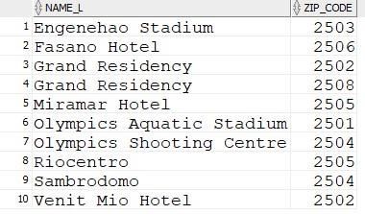

insert into arena values ('Olympics Aquatic Stadium', 2501,15000); insert into arena values ('Engenehao Stadium', 2503,60000); insert into arena values ('Olympics Shooting Centre', 2504,10000); insert into arena values ('Sambrodomo', 2504,9000); insert into arena values ('Riocentro', 2505,36000); select * from arena;

ACCOMODATION

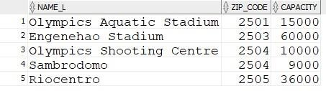

insert into accomodation values ('Miramar Hotel', 2505); insert into accomodation values ('Fasano Hotel', 2506); insert into accomodation values ('Venit Mio Hotel', 2502); insert into accomodation values ('Grand Residency', 2502); insert into accomodation values ('Grand Residency', 2508); select * from accomodation;

TICKETS

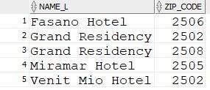

insert into tickets values ('A1',102,'01-05-2016',550,'Engenehao Stadium', 2503); insert into tickets values ('A1',103,'01-05-2016',1000,'Engenehao Stadium', 2503); insert into tickets values ('A1',102,'03-05-2016',2000,'Sambrodomo', 2504); insert into tickets values ('B1',103,'03-05-2016',2000,'Sambrodomo', 2504); insert into tickets values ('A1',105,'10-05-2016',1500,'Riocentro', 2505); select * from tickets;

PERSON

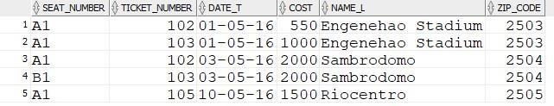

insert into person values ('Usain Bolt','A1','Venit Mio Hotel', 2502,'M'); insert into person values ('Justin Gatlin','A2','Venit Mio Hotel', 2502,'M'); insert into person values ('Andre De Grasse','A3','Grand Residency', 2508,'M'); insert into person values ('Yohan Blake','A4','Grand Residency', 2508,'M'); insert into person values ('P. V. Sindhu','A5','Fasano Hotel', 2506,'F'); insert into person values ('Nozomi Okuhara','A6','Fasano Hotel', 2506,'F'); insert into person values ('Carolina Marin','A7','Fasano Hotel', 2506,'F'); insert into person values ('Anna Kortozaki','O1','Grand Residency', 2502,'M'); insert into person values ('Monika Karsch','O2','Miramar Hotel', 2505,'F'); insert into person values ('Heidi Diethelm Gerber','O3','Venit Mio Hotel', 2502,'M'); select * from person;

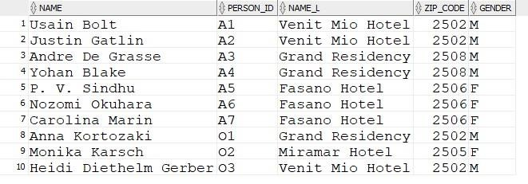

# ATHELETE

insert into athelete values ('Jamaica','Men''s 100M',12,'A1'); insert into athelete values ('USA','Men''s 100M',34,'A2'); insert into athelete values ('Canada','Men''s 100M',20,'A3'); insert into athelete values ('South Africa','Men''s 100M',15,'A4'); insert into athelete values ('India','Badminton Women''s Single',9,'A5'); insert into athelete values ('Japan','Badminton Women''s Single',56,'A6'); insert into athelete values ('Spain','Badminton Women''s Single',2,'A7'); select * from athelete;

OFFICIAL

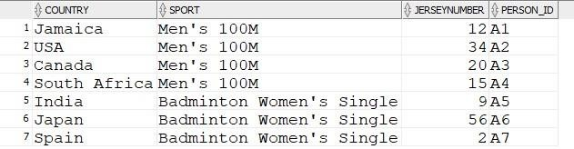

insert into official values ('Y','Y','N','O1'); insert into official values ('N','Y','Y','O2');

insert into official values ('Y','Y','Y','O3');

select * from official;

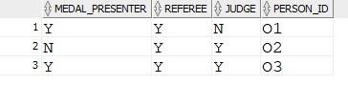

# TRANSPORT

insert into Transport values ('B01',100); insert into Transport values ('B02',120); insert into Transport values ('B03',50); insert into Transport values ('B04',75);

insert into Transport values ('B05',60);

select * from Transport;

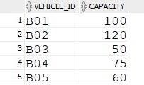

# FIXTURES

insert into fixtures values ('M1','Badminton Women''s Final','09:00 AM','01-05-2016','Engenehao Stadium',

2503);

insert into fixtures values ('M2','Men''s 100M','05:00 PM','03-05-2016','Sambrodomo', 2504); insert into fixtures values ('M3','Men''s 100M Final','11:00 AM','10-05-2016','Riocentro', 2505); select * from fixtures;

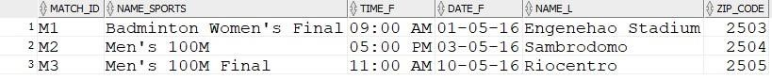

# USES

insert into uses values ('B05','A1'); insert into uses values ('B05','A2'); insert into uses values ('B01','A2'); insert into uses values ('B03','A3'); insert into uses values ('B03','A4'); insert into uses values ('B01','A5'); insert into uses values ('B01','A6'); insert into uses values ('B01','A7'); insert into uses values ('B01','O1'); insert into uses values ('B04','O1'); insert into uses values ('B05','O2'); insert into uses values ('B02','O3');

insert into uses values ('B05','O3');

select * from uses;

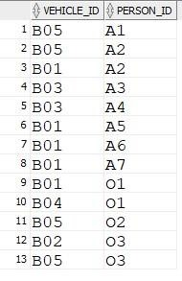

# PARTICIPATES_ORGANISES

insert into Participates_Organises values ('M1','A5'); insert into Participates_Organises values ('M1','A6'); insert into Participates_Organises values ('M1','A7'); insert into Participates_Organises values ('M1','O3'); insert into Participates_Organises values ('M2','A2'); insert into Participates_Organises values ('M2','A3'); insert into Participates_Organises values ('M2','A4'); insert into Participates_Organises values ('M2','O1'); insert into Participates_Organises values ('M2','O2'); insert into Participates_Organises values ('M3','A1'); insert into Participates_Organises values ('M3','A2'); insert into Participates_Organises values ('M3','A3'); insert into Participates_Organises values ('M3','O1'); insert into Participates_Organises values ('M3','O3'); select * from Participates_Organises;

RESULT

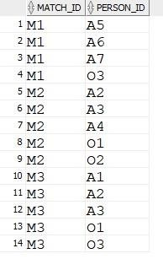

insert into result values ('Spain',1,'M1'); insert into result values ('India',2,'M1'); insert into result values ('Japan',3,'M1'); insert into result values ('Canada',1,'M2'); insert into result values ('USA',2,'M2'); insert into result values ('South Africa',3,'M2'); insert into result values ('Jamaica',1,'M3'); insert into result values ('USA',2,'M3'); insert into result values ('Canada',3,'M3'); select * from result;

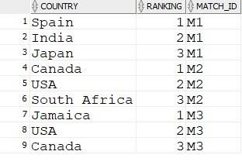

# SPONSORS

insert into sponsors values ('Coca Cola',501); insert into sponsors values ('Lenovo',502); insert into sponsors values ('Ferrari Ltd.',503); insert into sponsors values ('Subway',504); select * from sponsors;

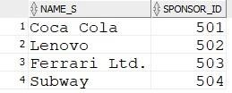

# SPONSORED_BY

insert into sponsored_by values (501,'M1'); insert into sponsored_by values (502,'M1'); insert into sponsored_by values (501,'M2'); insert into sponsored_by values (501,'M3'); insert into sponsored_by values (503,'M3'); insert into sponsored_by values (504,'M3'); select * from sponsored_by;

EQUIPMENT

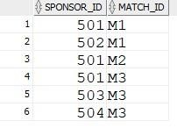

insert into equipment values (901,'Badminton Racket',2100,40); insert into equipment values (902,'Badminton Shuttle',100,20); insert into equipment values (903,'Drones',3000,10); select * from equipment;

REQUIRE

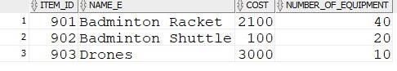

insert into require values (901,'M1'); insert into require values (902,'M1'); insert into require values (903,'M1'); insert into require values (903,'M2'); insert into require values (903,'M3'); select * from require;

TRAVELS_TO

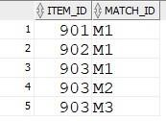

insert into travels_to values ('08:30 AM','01-05-2016','Engenehao Stadium',2503,'A5','B01'); insert into travels_to values ('08:30 AM','01-05-2016','Engenehao Stadium',2503,'A6','B01'); insert into travels_to values ('08:30 AM','01-05-2016','Engenehao Stadium',2503,'A7','B01'); insert into travels_to values ('08:00 AM','01-05-2016','Engenehao Stadium',2503,'O3','B02'); insert into travels_to values ('04:30 PM','03-05-2016','Sambrodomo', 2504,'A2','B01'); insert into travels_to values ('04:30 PM','03-05-2016','Sambrodomo', 2504,'A3','B03'); insert into travels_to values ('04:30 PM','03-05-2016','Sambrodomo', 2504,'A4','B03'); insert into travels_to values ('04:00 PM','03-05-2016','Sambrodomo', 2504,'O1','B04'); insert into travels_to values ('04:00 PM','03-05-2016','Sambrodomo', 2504,'O2','B05'); insert into travels_to values ('10:30 AM','10-05-2016','Riocentro', 2505,'A1','B05'); insert into travels_to values ('10:30 AM','10-05-2016','Riocentro', 2505,'A2','B05'); insert into travels_to values ('10:00 AM','10-05-2016','Riocentro', 2505,'A3','B03'); insert into travels_to values ('10:00 AM','10-05-2016','Riocentro', 2505,'O1','B01'); insert into travels_to values ('10:00 AM','10-05-2016','Riocentro', 2505,'O3','B05'); select * from travels_to;

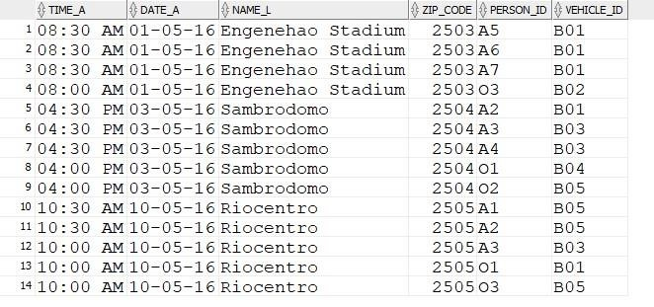

# TRAVELS_FROM

insert into travels_from values ('03:30 PM','01-05-2016','Engenehao Stadium',2503,'A5','B01'); insert into travels_from values ('03:30 PM','01-05-2016','Engenehao Stadium',2503,'A6','B01'); insert into travels_from values ('03:30 PM','01-05-2016','Engenehao Stadium',2503,'A7','B01'); insert into travels_from values ('05:00 PM','01-05-2016','Engenehao Stadium',2503,'O3','B02'); insert into travels_from values ('10:30 PM','03-05-2016','Sambrodomo', 2504,'A2','B01'); insert into travels_from values ('11:30 PM','03-05-2016','Sambrodomo', 2504,'A3','B03'); insert into travels_from values ('11:30 PM','03-05-2016','Sambrodomo', 2504,'A4','B03');

insert into travels_from values ('10:30 PM','03-05-2016','Sambrodomo', 2504,'O1','B04'); insert into travels_from values ('10:30 PM','03-05-2016','Sambrodomo', 2504,'O2','B05'); insert into travels_from values ('05:30 PM','10-05-2016','Riocentro', 2505,'A1','B05'); insert into travels_from values ('05:30 PM','10-05-2016','Riocentro', 2505,'A2','B05'); insert into travels_from values ('06:00 PM','10-05-2016','Riocentro', 2505,'A3','B03'); insert into travels_from values ('07:00 PM','10-05-2016','Riocentro', 2505,'O1','B01'); insert into travels_from values ('05:30 PM','10-05-2016','Riocentro', 2505,'O3','B05'); select * from travels_from;

